System security Lab-5

Praneesh R V

CB.SC.U4CYS23036

Chapter 1:

1.15:

Q1.)

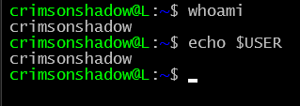

Q2.)



Q3.)

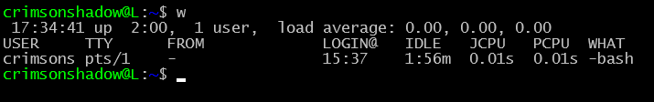

Q4.)



Q5.)

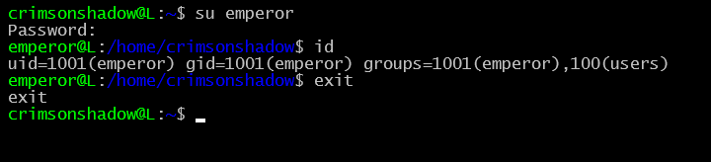

Q6.)

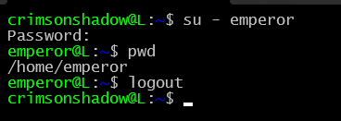

Q7.)

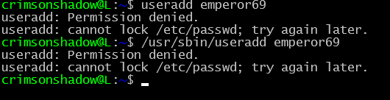

Q8.)

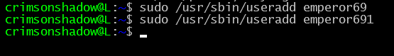

Chapter 2:

2.13:

Q1.)

Q2.)

Q3.)

Q4.)

Q5.)

Q7.)

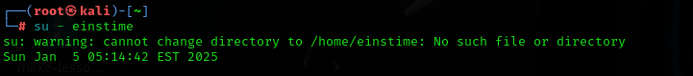

Q8.)

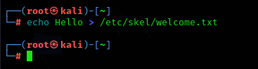

Q9.)

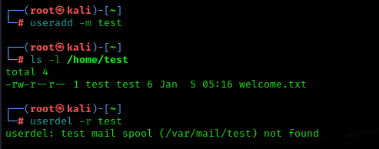

Q10.)

Chapter 3:

3.10:

Q1.)

Q2.)

Q3.)

Q4.)

Ans.) Locking will prevent the user from logging into the system with the password and disabling will erase the password from /etc/shadow

Q5.)

Q6.)

Q7.)

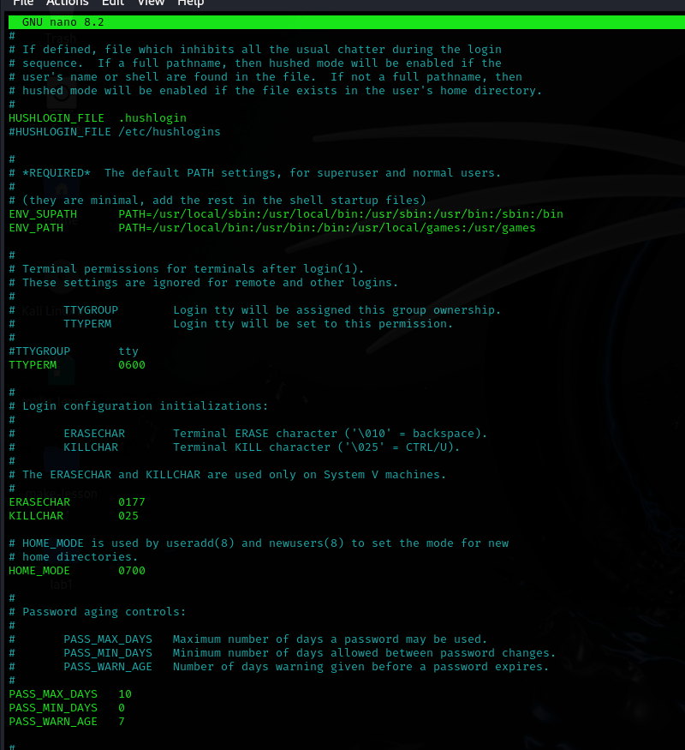

Q8.)

Ans.) Yes

Q9.)

Ans.) vipw will give a warning when someone else is already using that file

Q10.)

Q11.)

Ans.)-d

Q12.)

Chapter 4:

4.9:

Q1.)

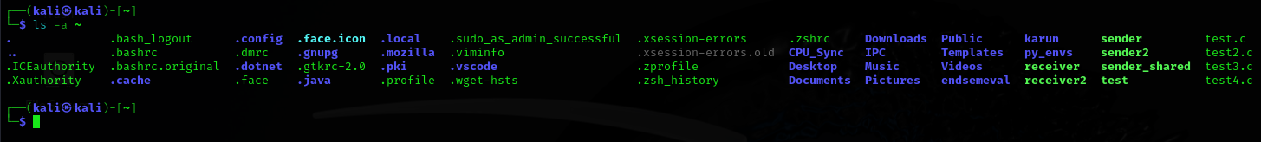

Q3.)

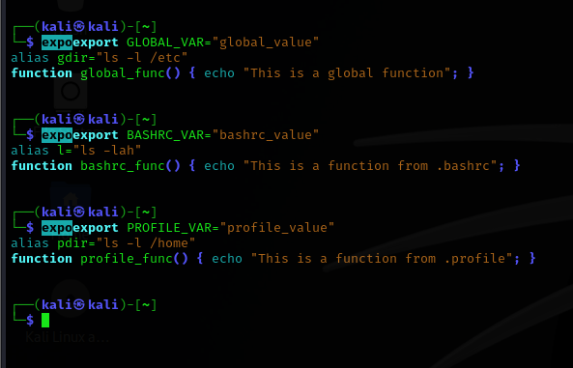

Q4.)

Q5.)

Ans.) It is in the order name, aliases, functions and variable respectively.

Q6.)

Ans.) Yes

Chapter 5:

5.10:

Q1.)

Q2.)

Q3.)

Q4.)

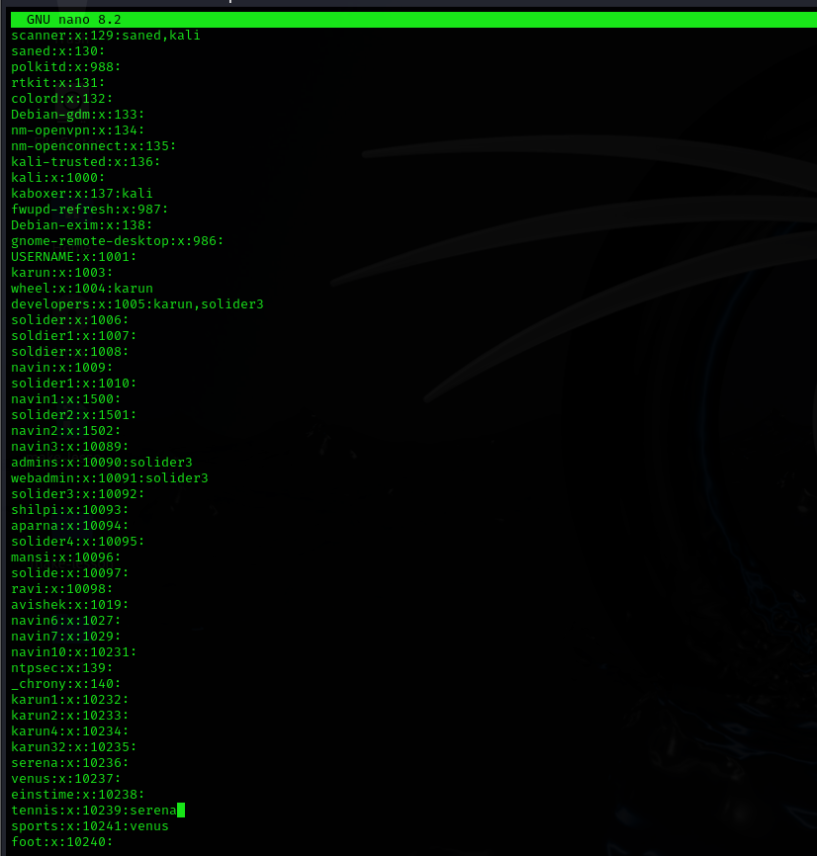

Q5.)

Q6.)

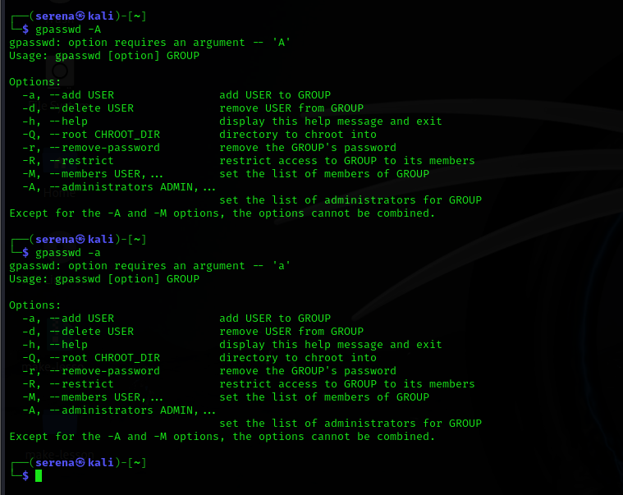

Chapter 6:

Q1.)

Q2.)

Q3.)

Q4.)

Q5.)

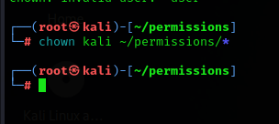

Q6.)

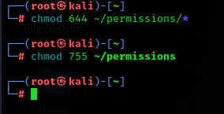

Q7.)

Ans.) Yes

Q8.)

Ans.) No

Q9.)

Ans.) Yes

Q10.)

Ans.) No

Q11a.)

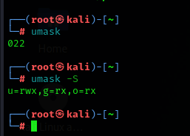

Q11b.)

Q12.)



Q13a.)

Yes, they can read

Q13b.)

Ans.) Yes root can read this file

Q14.)

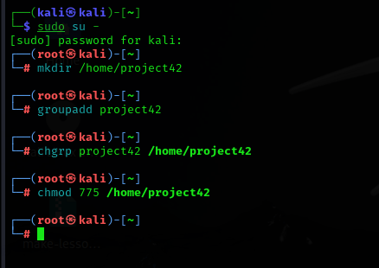

Chapter 7:

7.5:

Q1a.)

Q1b.)

Q1c.)

Q1d.)

Q1e.)

Q2.)

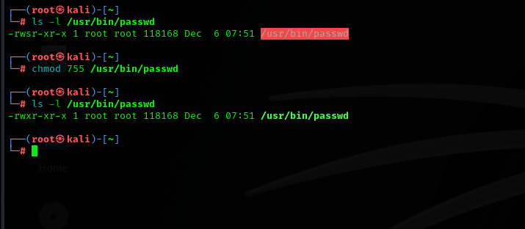

Q3.)

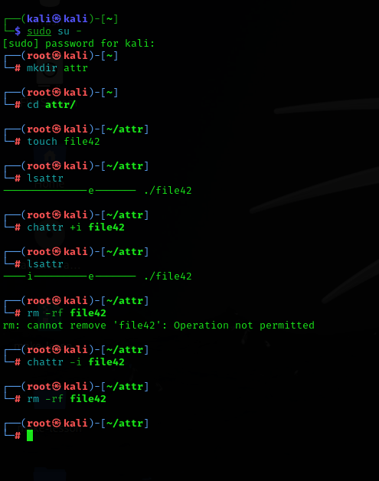

Chapter 9:

9.6:

Q1.)

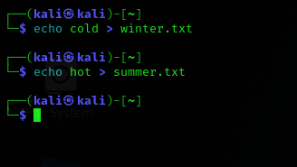

Q2.)

Q3.)

Q4.)

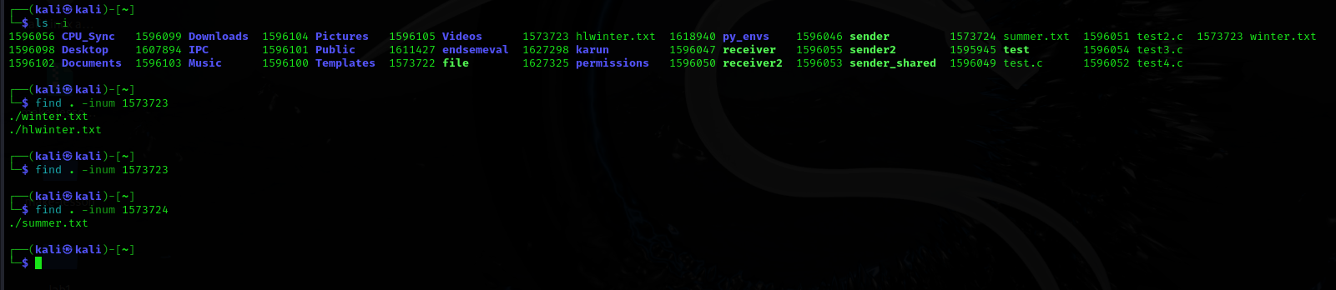

Q5.)

Ans.) name of the file in directory and the contents is stored in the disk.

Q6.)

Q7.)

Q8.)

Q9.)

Q10.)

